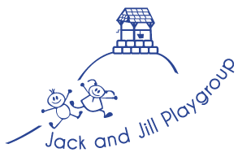

**Practical Tips for a Healthy Lunchbox**

When purchasing food for your child`s lunchbox, check the traffic light guide on packaging as this indicates how much salt, sugar and fat are in those products.

Try to vary the contents of the lunchbox daily. That way you can ensure your child is getting the variety of nutrients their bodies need to function and grow.

Involve your child in preparing their lunchbox. They are more likely to enjoy food they have made themselves.   
To keep food fresh, make sure it is stored properly: lunchboxes packed the night before need to be stored in the fridge. If using rice, make sure it is cooled quickly and stored in the fridge overnight.

To keep lunch fresh during the day you could use a cool bag and put in a reusable ice pack.

Using different breads will make the lunchbox more interesting and enjoyable.  
If your child refuses to eat brown bread, try a lighter variety or make sandwiches using a slice of white and a slice of wholemeal bread.  
For variety, use pitta strips, crackers, breadsticks, or fruit and vegetable finger foods with a dip.  
Always try to add a little salad to a sandwich.  
You can use leftovers; for example, rice and curry, vegetable pizza or pasta and sauce. Make a salad using rice, potato or pasta from the night before, mixed with vegetables, beans and so on.

**We encourage home cooked meals, which we are happy to re-heat at lunch time.**

**We follow current food preparation guidelines.**

**Jack and Jill Playgroup  
Healthy Packed Lunches for Children**

**What you need to know**

**Eating well is important. Children need to eat well as it will give them energy and nutrients to grow and develop, be healthy and active.  
  
A healthy, enjoyable lunch gives children the energy they need to learn and play.**

**Use the information in this leaflet to help make your child a healthier packed lunch. Please support our playschool`s diet policy and procedures by following these guidelines.**

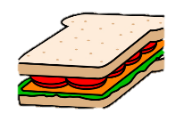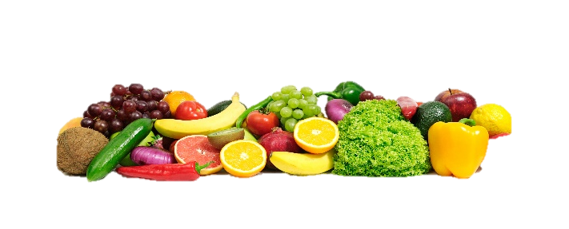

**Drinks**

Drinks, especially water, help children concentrate and feel well. Water is freely available in playschool in all areas.  
**Don’t worry about including a drink in lunchboxes as we provide this!**

**Starchy Foods**  
Base each meal on a starchy food, such as bread, potato, rice, pasta, yam.  
Starchy foods give energy, fibre, vitamins and minerals.

* Bread, try different types, such as pitta bread, wraps, chapattis or bread rolls.
* Other starchy foods, such as pasta, couscous or rice.  
  Whole grain varieties are best for fibre, which is vital for a healthy digestive system.

**Meat and Alternatives**  
Add some protein, for example meat, fish, eggs, beans or pulses. Protein foods build muscles and provide minerals.

* Lean meats, such as chicken, turkey or ham.
* Include oily fish, such as pilchards, sardines or mackerel at least once every three weeks.
* Cheese, such as cottage cheese, edam or soft cheese.
* Egg, such as quiche or omelette.
* Meat alternatives, such as tofu or tempeh.
* Dishes containing pulses, beans or meat, for example dahl, stew or bean salad.
* Meat products such as sausage rolls, sausages and chipolatas, pies and pastries are not encouraged.
* Use butter, margarine, mayonnaise or salad dressings sparingly, because these can be high in fat, or use lower fat alternatives.
* **The playschool does not allow any type of nuts in packed lunches.**

**Snack and confectionery**

Snack foods may be included occasionally but aim to make healthier choices. Snack foods tend to be high in fat, sugar and salt. Foods high in fat can cause excessive weight and may lead to heart disease. High sugar foods are high in calories and bad for teeth. High salt foods may increase blood pressure, which can lead to heart disease and some cancers.

**For a healthier snack:**

Replace sweets and chocolate with dried fruit, a small bunch of grapes or fruit salad.

Replace cakes and pastries with fruit bread or malt load.

Replace salted savoury snacks with rice cakes or breadsticks.

Packed lunches should not contain chocolate, biscuits, sweets, salted savoury snacks, cereal bars, fizzy drinks or juice drinks.

**Please do not include peanut butter or chocolate spread filling for sandwiches.**

**What is a healthy packed lunch?**

**A healthy packed lunch, is a balanced meal providing a variety of nutrients, to be found in four food groups**

**Milk and Dairy foods**  
Include a dairy product or dairy alternative, such as fromage frais. These foods provide calcium necessary for strong bones and teeth, as well as providing protein and vitamins.  
Lower fat varieties are healthier.  
 **Fruit and Vegetables**  
Don’t forget to include fruit and vegetables. Fruit and vegetables are full of vitamins, minerals and fibre necessary for the body to function properly and to keep you strong and healthy.

* Add tomato, lettuce or beetroot to a sandwich.
* A vegetable dish, such as salad or roast vegetables.
* Fresh fruit, such as apple, banana or pear.
* Dried fruit, such as apricots or figs.
* Fruit salad (fresh or tinned in juice) or vegetable salad.
* Finger foods, such as cherry tomatoes, cucumber sticks or celery. Good with a dip, such as humous or guacamole.
* **Aim to include at least one portion of fruit and one portion of vegetable or salad in each packed lunch.**